**Exercise - Push a change through the pipeline**

In this part, you see your deployment slots in action. On the website's home page, you change the background color and the text on the hero banner. You then push your changes to GitHub, watch the pipeline run, and verify the changes.

To further practice the process, you then revert your changes and watch the pipeline run as a way of *rolling forward*.

**Change the text on the hero banner**

Here you change the text on the hero banner. Later you'll see the change when you deploy to App Service.

1. In Visual Studio Code, in the *Tailspin.SpaceGame.Web/Views/Home* directory, open *Index.cshtml*.
2. Look for this text near the top of the page:

**HTML**

<p>An example site for learning</p>

**Tip**

Visual Studio Code provides a way to search for text in files. To access the search pane, select the magnifying glass icon in the side pane.

1. Replace the example text with the following text, and then save the file.

**HTML**

<p>Welcome to the official Space Game site!</p>

**Change the background color**

Here you change the background color of the hero banner from gray to green.

1. In Visual Studio Code, in the *Tailspin.SpaceGame.Web/wwwroot/css* directory, open *site.scss*.

**Important**

Open *site.scss*, not *site.css*. The *Build* stage runs node-sass to convert *site.scss* (a Sass file) to *site.css* (a standard CSS file).

1. Locate the following code near the top of the file:

css

.intro {

height: 350px;

background-color: #666;

background-image: url('/images/space-background.svg');

background-size: 1440px;

background-position: center top;

background-repeat: no-repeat;

background-attachment: fixed;

1. In the code, replace the highlighted text as shown in the following example. Then save the file.

css

.intro {

height: 350px;

background-color: green;

background-image: url('/images/space-background.svg');

background-size: 1440px;

background-position: center top;

background-repeat: no-repeat;

background-attachment: fixed;

**Push the change through the pipeline**

Normally you would build and run the site locally to verify the change. You might also run any associated unit tests to verify that your change doesn't break existing functionality.

For brevity, here you commit the changes to your branch, push your branch to GitHub, and watch the pipeline run.

1. Add *Index.cshtml* and *site.scss* to the index, commit the changes, and then push the changes up to GitHub.

**Bash**

**git add Tailspin.SpaceGame.Web/Views/Home/Index.cshtml Tailspin.SpaceGame.Web/wwwroot/css/site.scss**

**git commit -m "Change text and colors on the home page"**

**git push origin blue-green**

1. In Azure Pipelines, trace the build through each step.
2. Go to the URL that corresponds to the *production* slot for your *Staging* environment. This slot is the default slot that you configured when you set up the pipeline earlier.

You see that the deployed website shows the color and text changes.

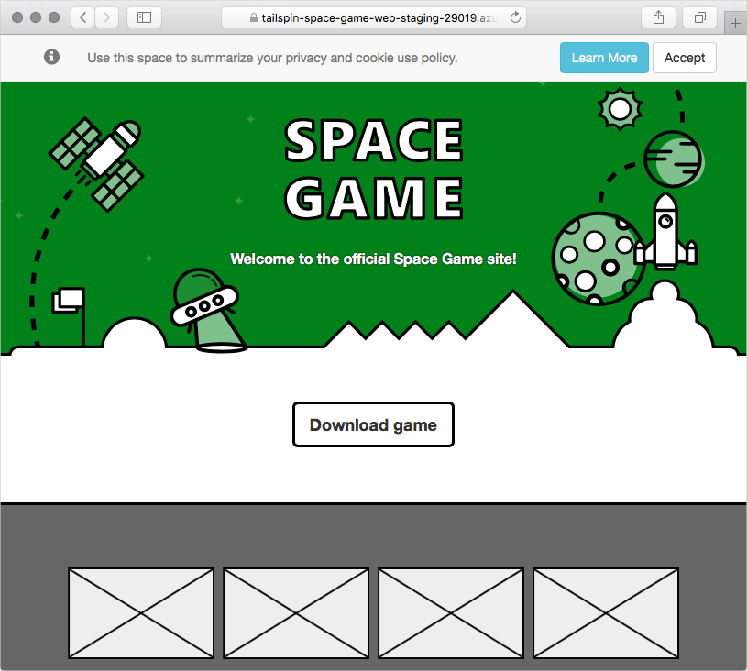

1. Go to the URL that corresponds to the *swap* slot for your *Staging* environment. The URL includes "-swap.azurewebsites.net" in its name.

You see the previous version of the website, without the color and text changes.

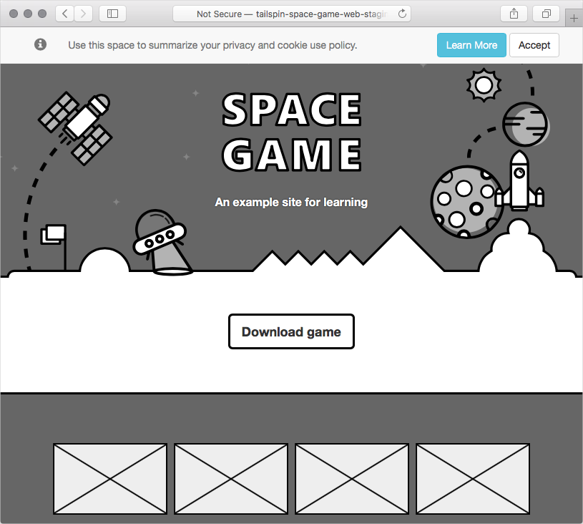

You see no changes because you swapped the *production* slot and the *swap* slot. In other words, here you always deploy to the *swap* slot, and then you swap the *production* slot and *swap* slot. The swap process ensures that the *production* slot points to the more recent deployment.

**Revert the change**

Let's say that you deployed a change that you want to revert. At this point, you could roll back the change by swapping the *production* slot and *swap* slot again. For example, you could swap the slots manually through the Azure portal. Or instead of rolling back the changes, you could roll forward by pushing another change through the pipeline.

That's what you'll do here. You'll revert your latest code changes and push another change through the pipeline. To do so, you use the git revert command.

In Git, you seldom remove commits from a file's history. Unlike the "undo" operation in a text editor, the git revert command creates a new commit that's essentially the opposite of the specified set of commits. To see the commits, you also run the git log command to trace your commit history during the revert process.

1. In your terminal, run the following git log command to view your commit history.

**Bash**

**git --no-pager log --oneline**

Your output resembles the following code example. In your output, you see additional commits and different commit IDs.

**Output**

06a26bd (HEAD -> blue-green) Change text and colors on the home page

e5e8fe5 Swap deployment slots

664d946 Trigger the pipeline

In the output, trace the commit history. The latest commit is on top.

1. Run the following git revert command to revert by one commit.

**Bash**

**git revert --no-edit HEAD**

Think of *HEAD* as the current state of your branch. HEAD refers to the latest commit. This command specifies to revert only the HEAD, or latest, commit.

1. Run git log again to see your updated commit history.

**BashCopy**

**git --no-pager log --oneline**

At the top of your output, you see an additional commit that reverts the previous commit. Here's an example:

**Output**

95fa0ac (HEAD -> blue-green) Revert "Change text and colors on the home page"

06a26bd Change text and colors on the home page

e5e8fe5 Swap deployment slots

664d946 Trigger the pipeline

**Push the reverted change through the pipeline**

Here you push your reverted change through the pipeline and see the results.

1. Run the following git push command to upload the blue-green branch to your GitHub repository.

**Bash**

**git push origin blue-green**

1. In Azure Pipelines, go to the build. Trace the build as it runs.
2. Go to the URLs that correspond to the *swap* slot and *production* slot for your *Staging* environment.

The *production* slot now points to your reverted change, which is the original website.



The *swap* slot now points to the previous change.



Great work! The team now has a way to automate the releases. They can get new features to their users without incurring downtime.

**Team meeting**

The team gathers to demo the pipeline. This time, Tim pushes a change through the pipeline while everyone watches. But not everyone's convinced.

**Andy:** It's great seeing deployment slots at work. But I don't get it. How do we benefit from zero-downtime deployments here? *Staging* is only for our team and management.

**Tim:** Indeed, we won't see much benefit right now. But imagine when we apply blue-green deployments to a *Production* stage. We'll still have the manual approval from management before we promote to *Production*. But when we do release new features, the swap process will make the rollout nearly instantaneous. It will be seamless to our users.

**Andy:** OK, I think I understand now. I like this improvement. The system of deployment slots was easy to set up, and it will benefit our users. Everyone wins.

**Amita:** Speaking of improvements, why don't we revisit our value-stream mapping exercise we did a few weeks ago? I bet we'll see progress in how quickly we can release new features.

**Mara:** Great, let's put that on the agenda for our next team meeting.